### Homework 5

Name: Eduardo Wang Zheng

E-mail: eduardo@sjtu.edu.cn

1. Experiments

1.1 Install dpdk

* + 1. Select the dpdk environment to build

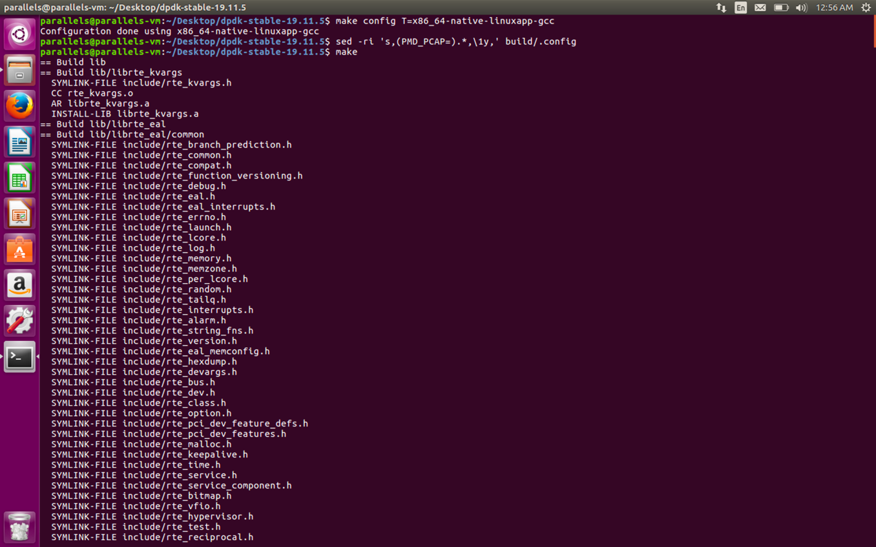

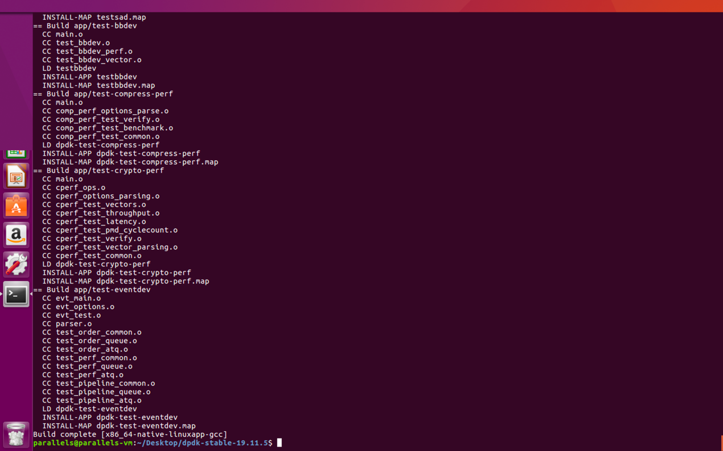

* + 1. Setup huge page mappings for numa systems

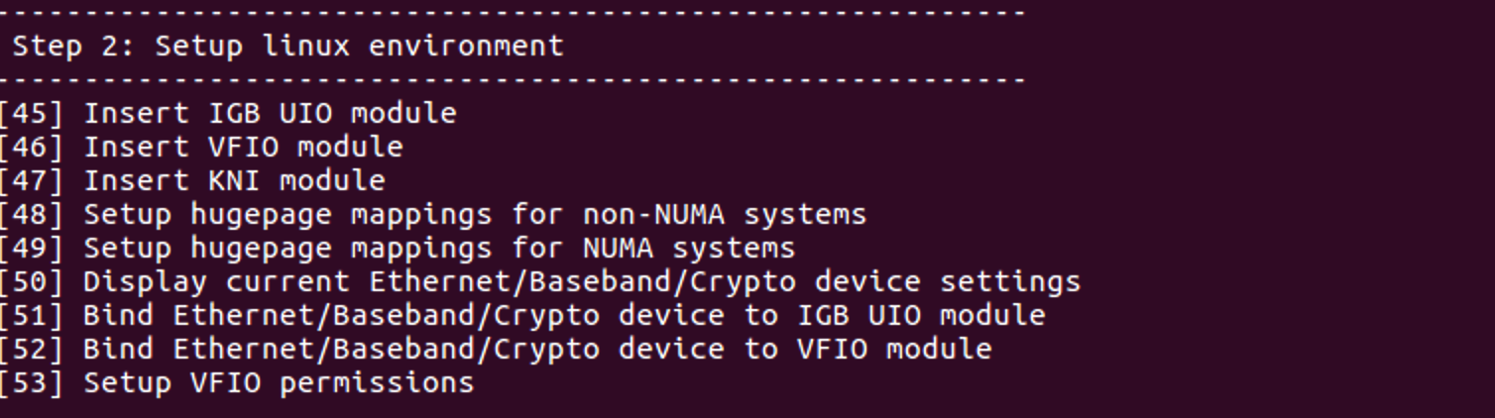

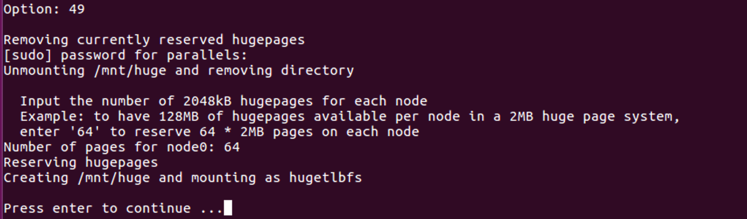

1.1.3 Check huge page mappings

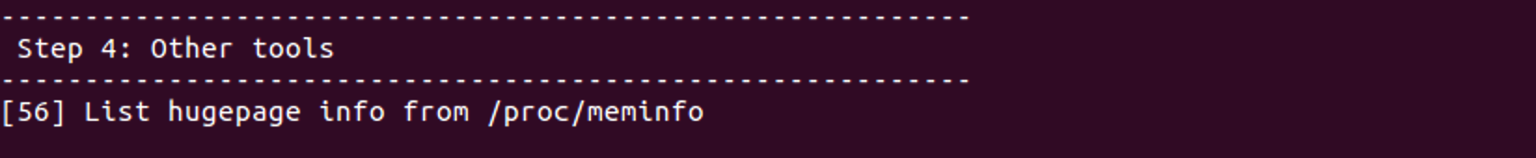

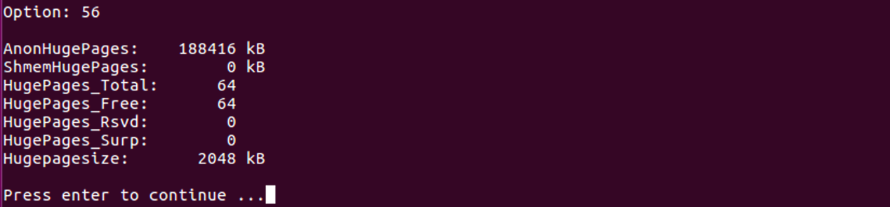

1.1.4 Check network devices

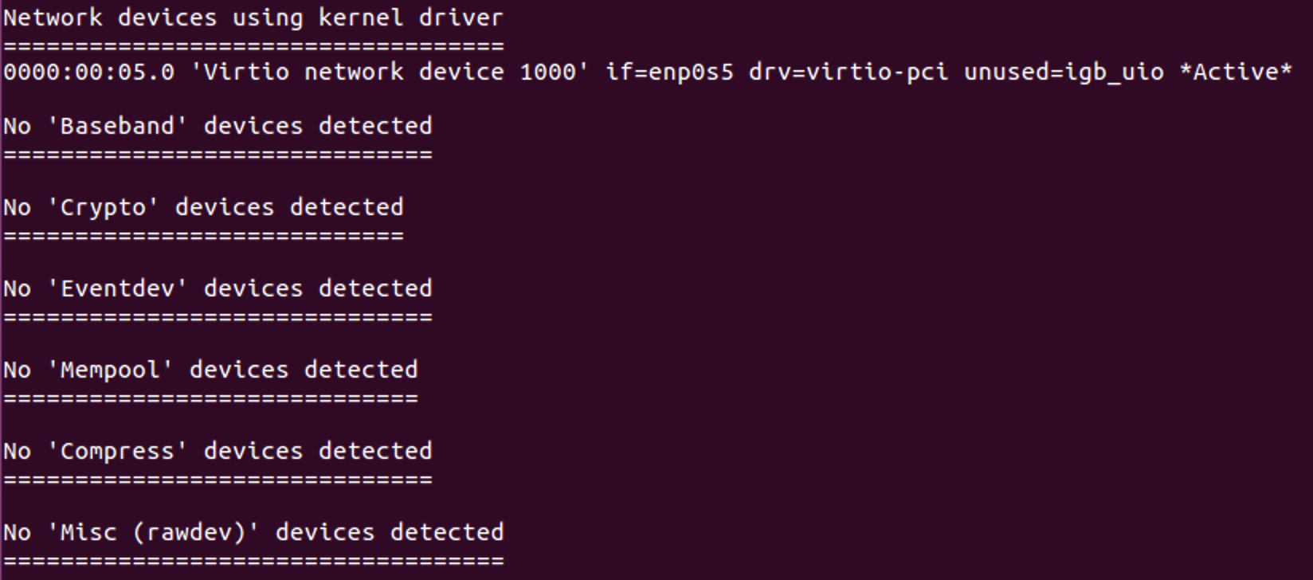

1.1.5 Inactivate network devices



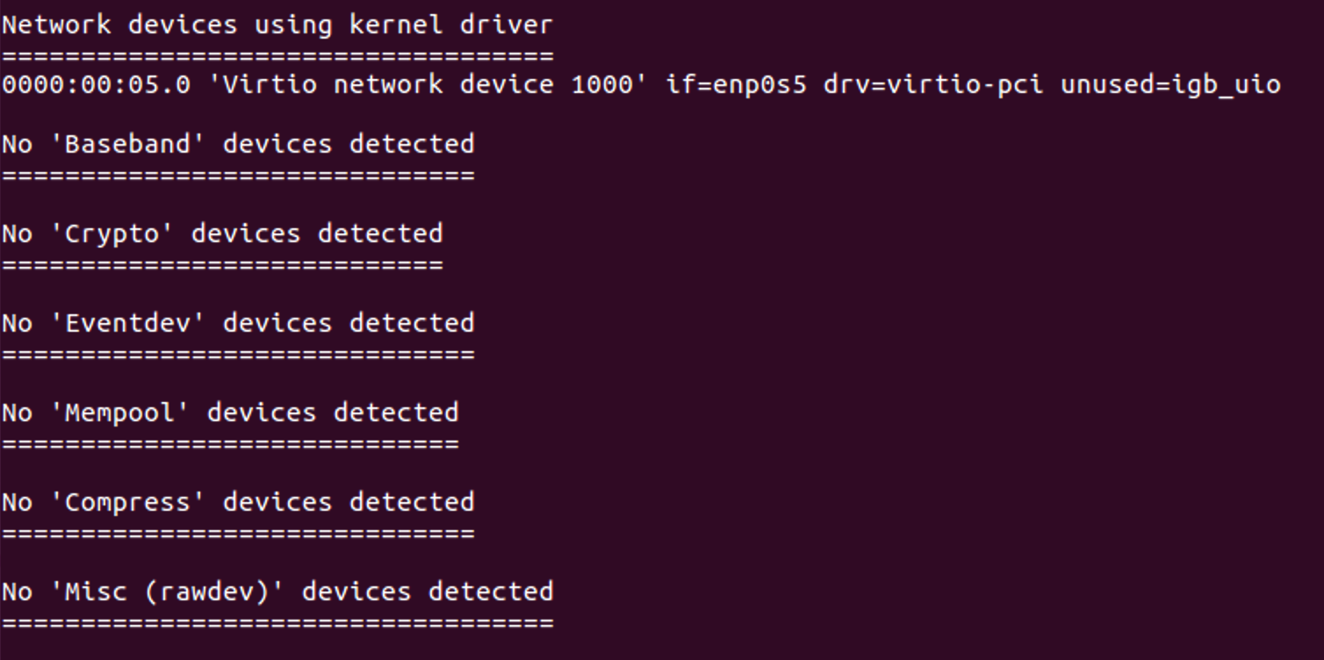

1.1.6 Bind network devices to IGB UIO driver



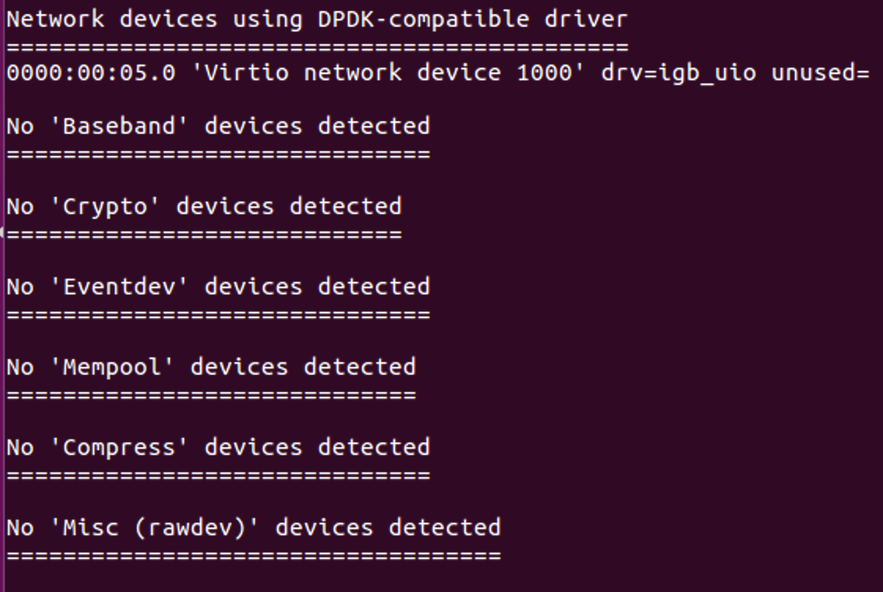

1.2 Compile and run DPDK sample application l2fwd

1.2.1 Compile DPDK sample application l2fwd

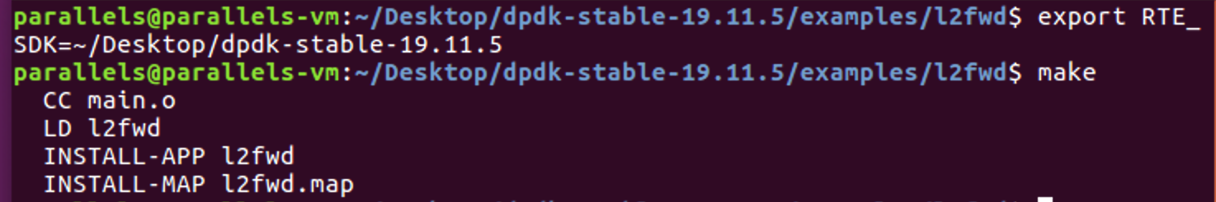

1.2.2 Run DPDK sample application l2fwd

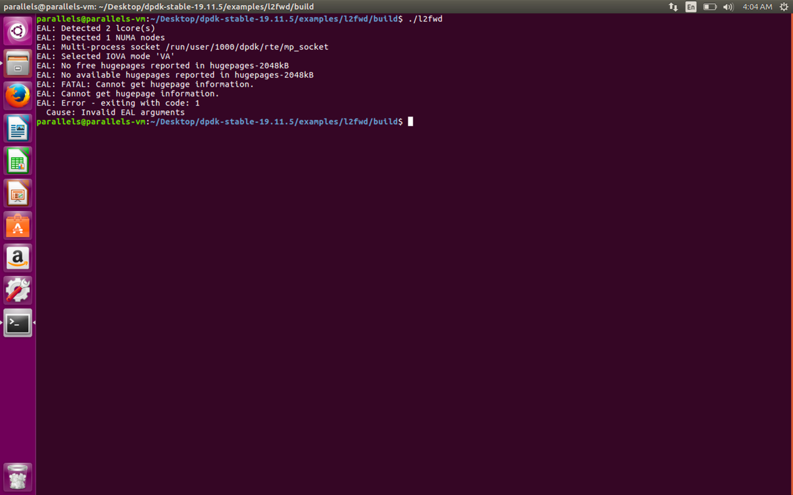

Problem 1: No available hugepages

Solution 1: Add more huge page mappings

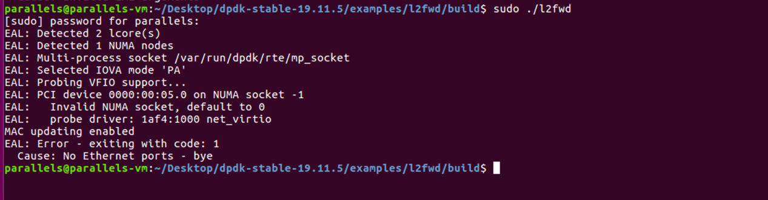

Problem 2: No Ethernet ports

Solution 2: Bind network devices to IGB UIO driver

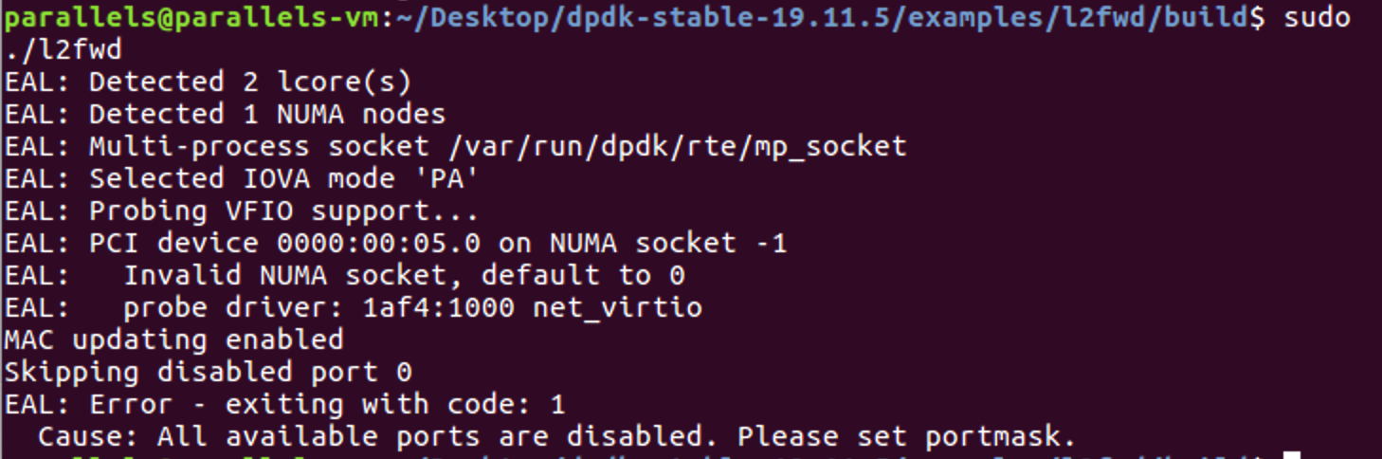

Problem 3: All available ports are disabled.

Solution 3: Set port mask to enable ports

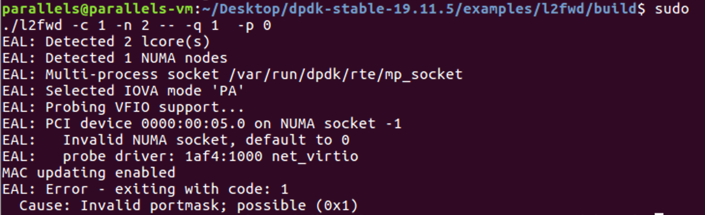

Problem 4: Invalid port mask

Solution 4: Use valid port mask (after parameter “-p”)

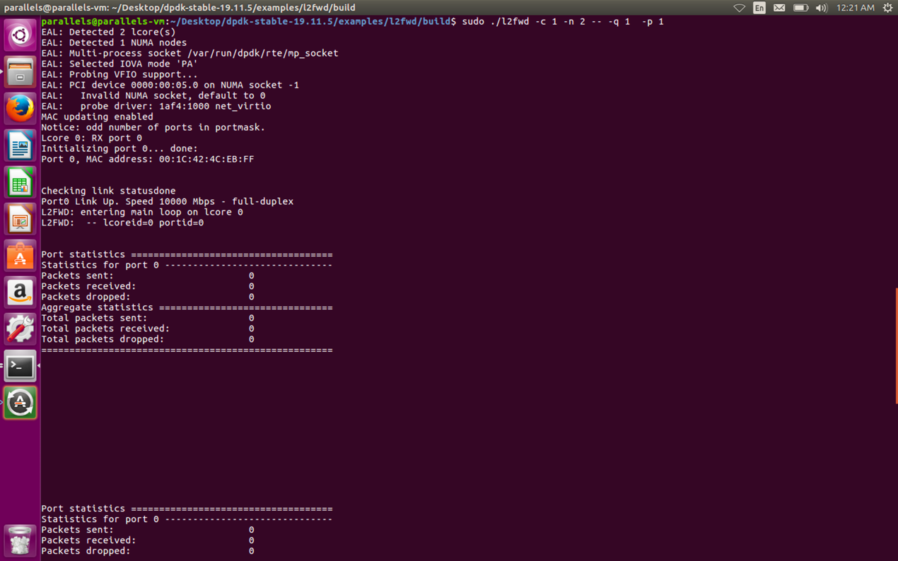

Successful run

1.3 Compile and run pktgen-dpdk

1.3.1 Compile pktgen-dpdk

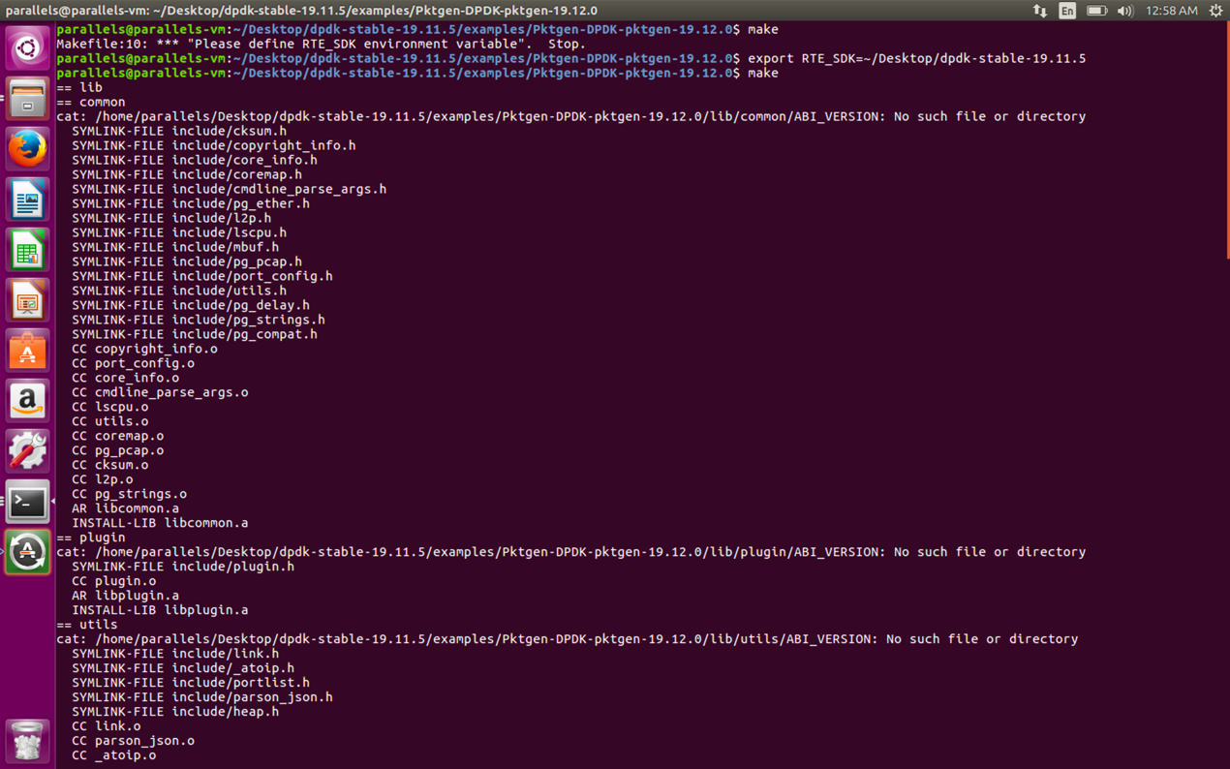

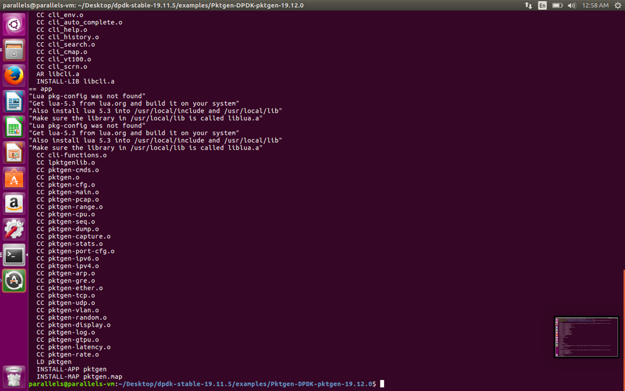

1.3.2 Run pktgen-dpdk

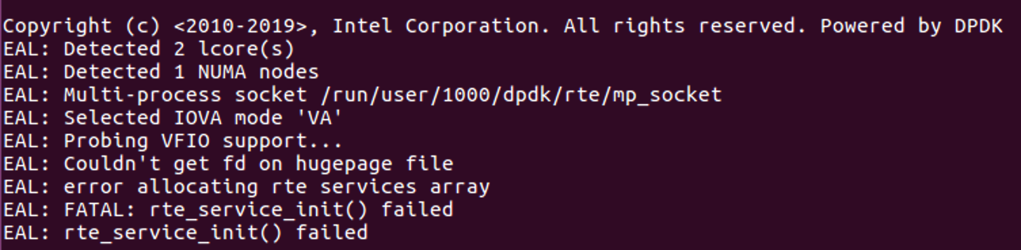

Problem 1: Couldn’t get fd on huge page file

Solution 1: Run as administer (use sudo)

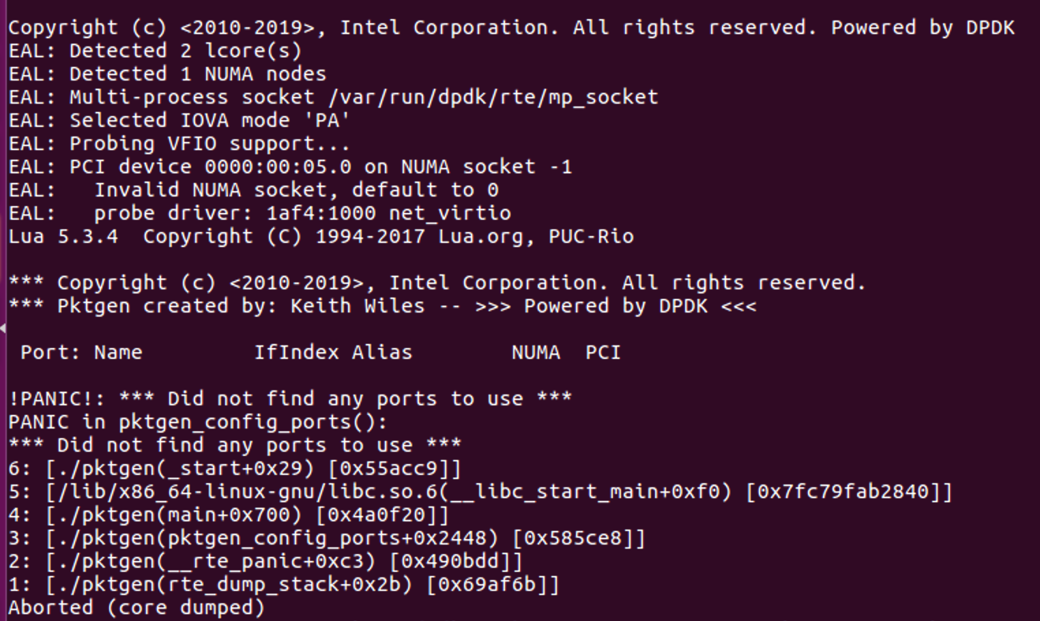

Problem 2: Did not find any ports to use

Solution 2: Specify parameters

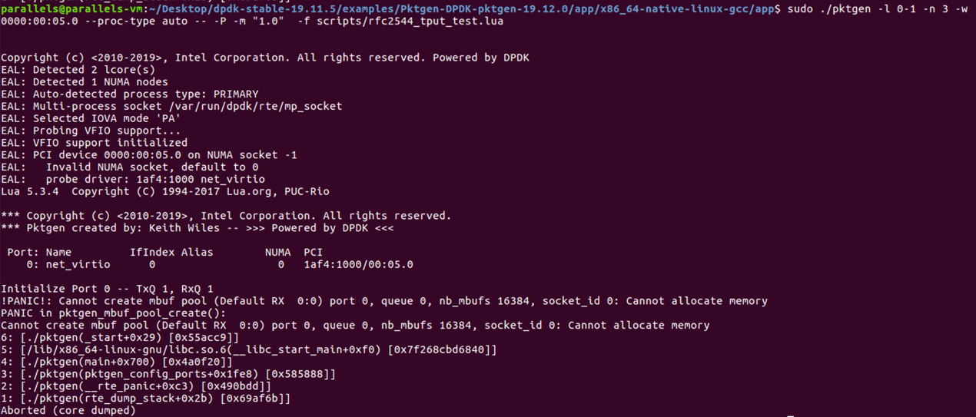

Problem 3: Cannot create mbuf pool

Solution 3: Add more huge page mappings

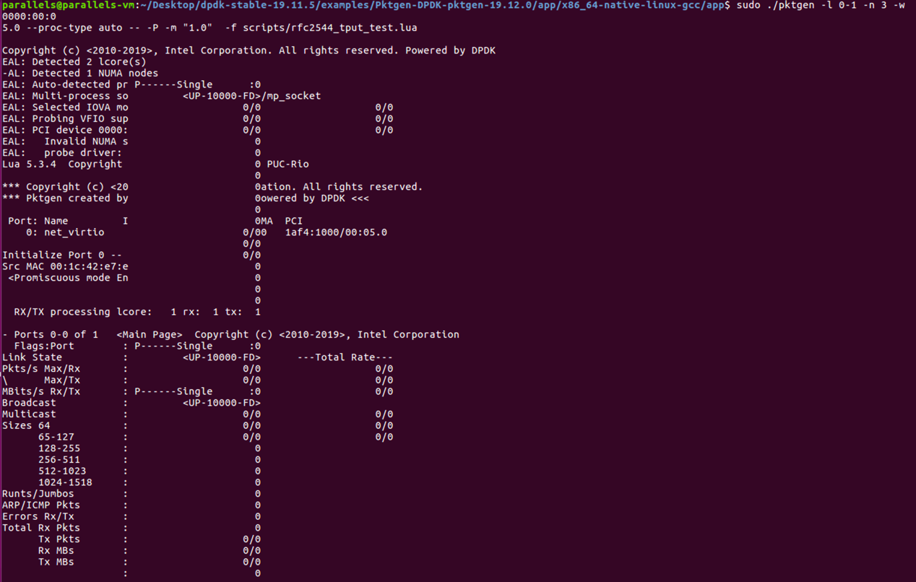

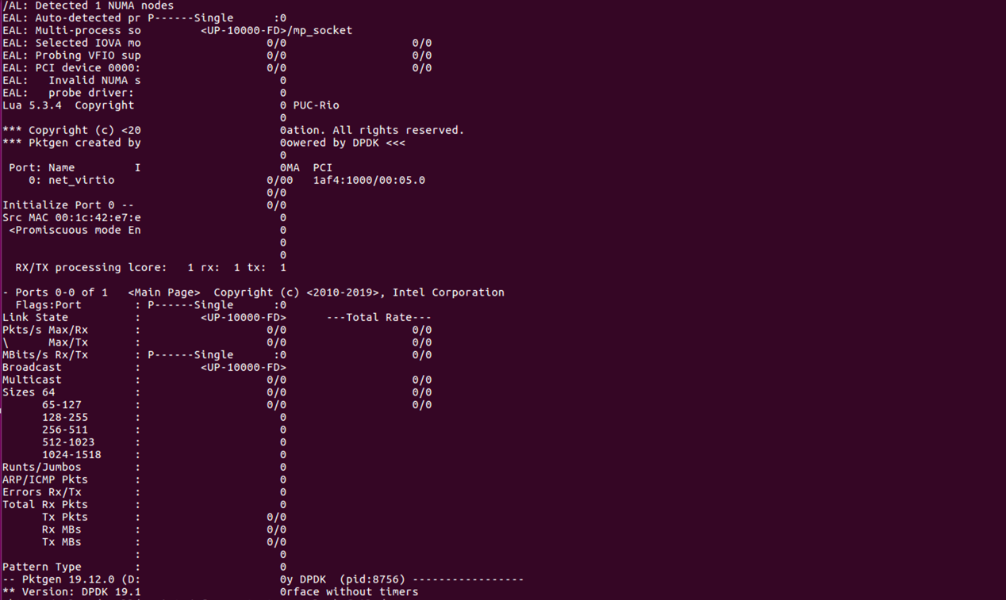

Successful run

1.4 “Whole picture”

I test **stp** and **str** command in pkgen-dpdk’s command line tool. The meaning of the command is as follows:

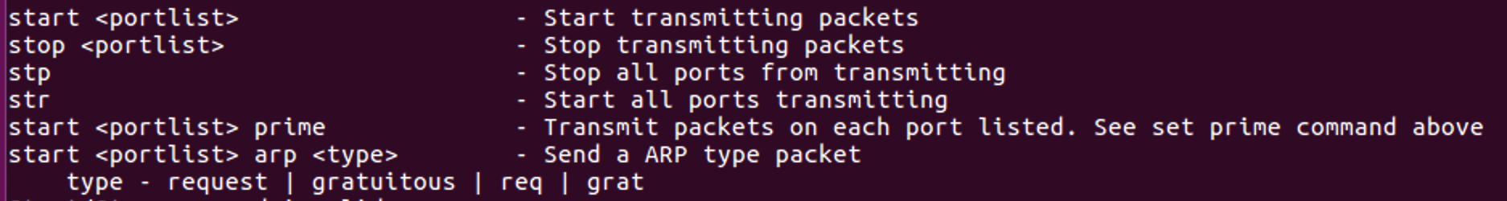

Now pkgen-dpdk will record the size of the packages VM1 sends and the amount of packages received from VM2, while l2fwd just send back the packages it received from VM1.

The followings are testing results:

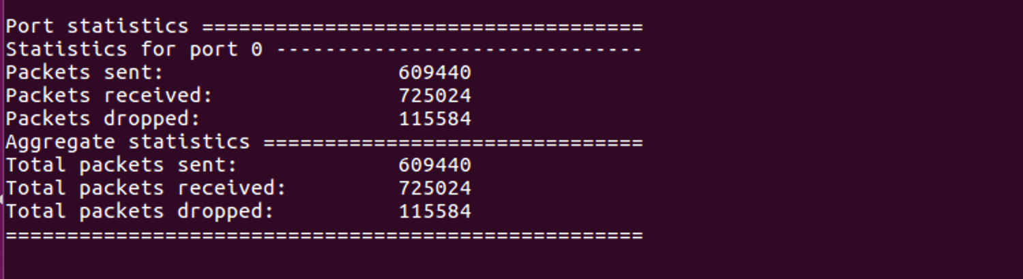

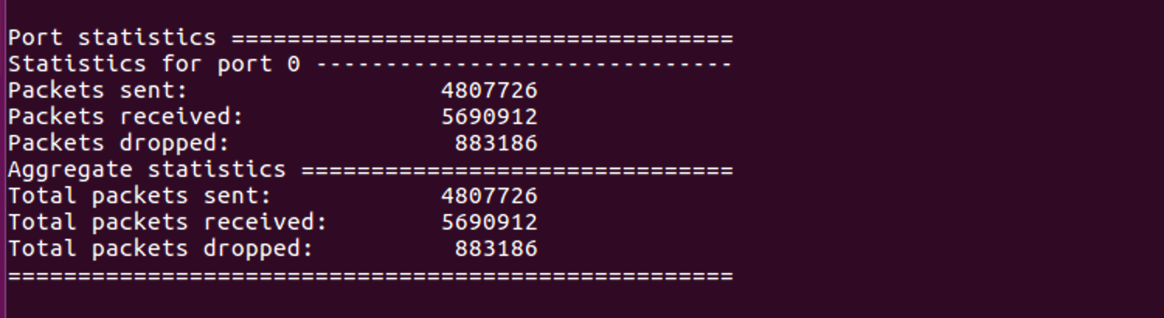

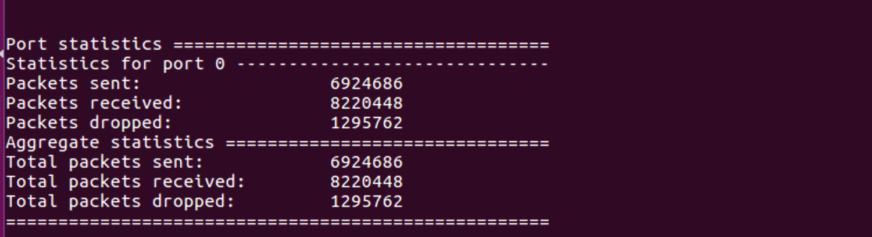

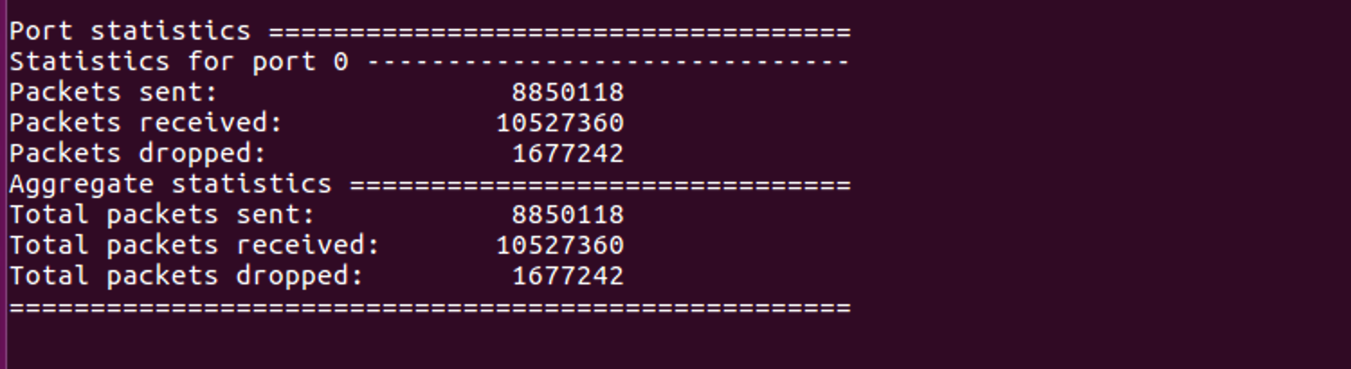

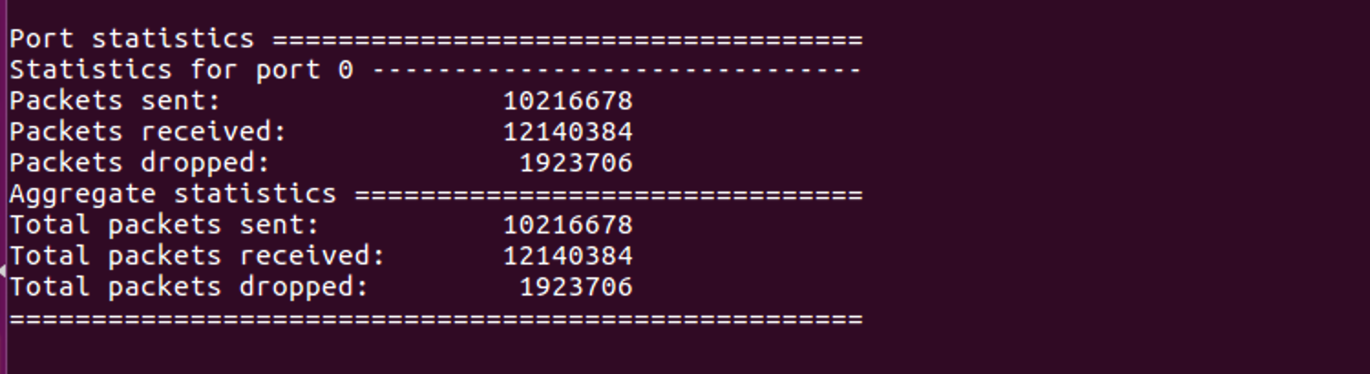

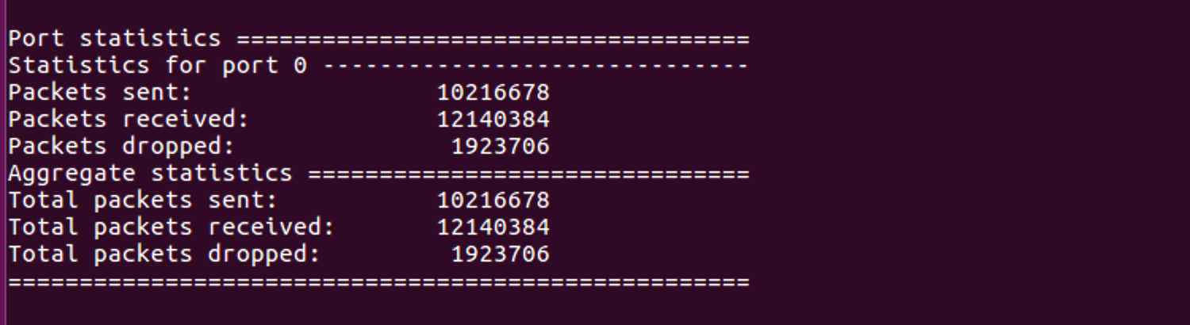

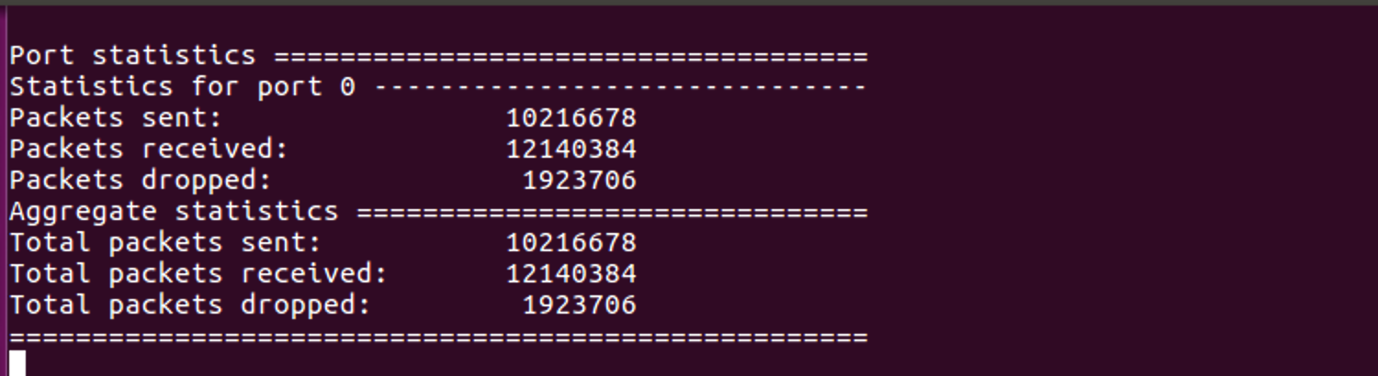

The output of l2fwd (as time goes by)

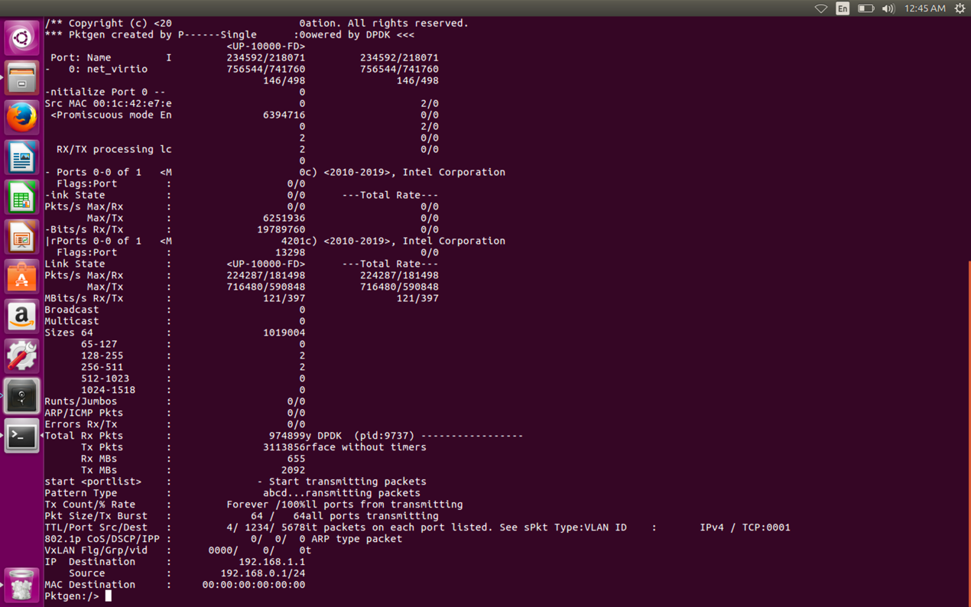

The output of pkgen-dpdk

1.5 Evaluate DPDK’s performance of L2 forwarding

The evaluation is as follows:

